Tackling a Worldwide Crisis: Obesity

*By Phil Davis, Ingrid Frayer, James Lawson, Lilly Mitchell, and Grace Sullivan*

April 21st, 2020

Obesity is a major issue that has affected countries across the globe. The World Health Organization (WHO) defines obesity as “abnormal or excessive fat accumulation that presents a risk to health.” Body mass index (BMI) is a function used to define obesity, calculated by dividing a person’s weight in kilograms by the square of their height in meters. A BMI greater than 30 is considered obese (WHO). Being obese presents major risk factors for chronic diseases such as diabetes, cardiovascular diseases and cancer. While obesity is often thought of as problematic only in wealthier countries, it has become a concern for middle and low-income countries as well (WHO).

The Organization for Economic Co-operation and Development (OECD) strives to create policies contributing to opportunity, prosperity, and well-being (Organization for Economic Co-operation and Development). The OECD draws on shared data collection and analysis to best advise policies from economic to social issues. To best identify factors contributing to obesity, we compare the US to Mexico, England and Korea. We chose these OECD countries as Mexico has a similarly high obesity rate, England exhibits a moderate obesity rate, and Korea has a low obesity rate.

**Healthcare Expenditures**

All countries of interest display a slight positive correlation between healthcare expenditure and obesity rate. However, the United States spends substantially more on healthcare than other OECD countries both in terms of percentage of GDP and per capita (Figure 1). A $900-billion increase in obesity-related healthcare costs has been predicted every decade for the US (Wang et al., 2008). This massive increase is attributed to the medical consequences of obesity. That being said, it is likely that the immense amount of money the US allocates for healthcare each year is an outcome of high obesity rates, rather than obesity prevention costs.

Trillions of dollars are spent in the US on healthcare, yet approximately $190 billion is allocated to specifically obesity-related treatment, a mere fraction of total expenditures (Cawley & Meyerhoefer, 2012). The US should implement obesity prevention programs to reduce the financial burden and decrease weight gain. Extensive meta-analyses have concluded that childhood obesity is a predictor for lifetime obesity; an obese child or adolescent is five times as likely to be obese as an adult (Simmonds, 2016). Implementing obesity prevention programs have shown to both successful and cost effective (Wang et al., 2008). Additionally, some programs have shown to reduce healthcare expenditures relating to obesity in the long-term, providing further support for childhood interventions (Sharifi et al., 2017). These interventions consist of either in-school or after-school programs focused on nutrition education and engagement in physical activity. While government mandating of these programs may initially appear costly, there would be a significant return on investment reflected in both spending and decreased obesity rates. Korea and England have observed a stabilization in child obesity rates in recent years, and this stagnation has been attributed to the implementation of government-regulated nutrition interventions in schools (Bae et al., 2012; Stamatakis et al., 2013). Obesity should be targeted at an early stage in the United States, modeled after these successful programs in other countries.

**Alcohol**

Previous research highlights a relationship between obesity and alcohol consumption dependent upon the amount of alcohol consumed. A meta-analysis failed to find a correlation between light and moderate alcohol consumption and obesity, but did observe a positive correlation between high alcohol consumption and obesity (Sayon-Orea et al., 2011). Furthermore, another review has suggested that moderate levels of alcohol consumption may even correlate negatively with obesity (Yeomans, 2010). Upon examining available OECD data, it appears that the data may follow this trend (Figure 2). While the United Kingdom has a moderate amount of alcoholic intake, the obesity rate has remained below 30% from 2000 to 2017. On the other hand, the United States displays high levels of alcohol consumption which is correlated with increased obesity rates from 2000 to 2017.

However, Korea does not follow this trend, displaying moderate consumption levels yet low obesity rates. Despite Korea’s marginally higher rates in alcohol consumption compared to the United States, a review comparing treatment options for addiction in both countries identified Korea as lacking in resources and professional support to adequately provide treatment as effectively as the US (Kim et al., 2013). However, it is unlikely that alcohol consumption is one of the main factors contributing to the United States. Average rates of alcohol consumption in Mexico are approximately half that of the United States, yet obesity rates are not significantly better. Data surrounding alcohol intake is inconclusive at this time; implementing superior interventions for alcohol abuse is likely not the answer.

**Environmental Impacts**

Environmental factors within a country can influence multiple aspects of human health. One aspect of human health that has a well-documented connection to air pollution is obesity. Multiple scientific papers have investigated this link, suggesting that exposure to ambient air pollution is associated with childhood risk for overweightness and obesity. According to WHO, over 80% of the global population living in urban areas is exposed to air quality levels that exceed WHO’s recommended limits. Research by WHO has suggested that air pollution may lead to unhealthy body weight through metabolic dysfunction, chronic disease onset, and disruption of regular physical activity (An et al., 2018). One of the main sources of air pollution is the transportation industry, specifically automobiles (EPA). Evidence suggests that childhood near-roadway air pollution (NRAP) exposures contribute to increased body mass index (BMI) (Carrington, 2018). Additional research has found that exposure to high levels of carbon monoxide, which is emitted by diesel engines, in the first year of life led to significantly faster weight gain later (Carrington, 2018). Our analysis focused on 2016 data and found that there is a correlation between obesity and air pollution in our target countries (Figure 3).

**GDP per Capita**

GDP per capita is a factor to consider when evaluating obesity data between countries. Countries with higher GDP per capita such as the United States and United Kingdom had a higher rate of obesity over the time span of 2000 to 2018 (Figures 4 and 5). Higher GDP per capita is not indicative of obesity, however, because Mexico, a country with lower GDP per capita (Figure 4), had obesity rates above that of the United Kingdom (Figure 5). One study examining the relationships between BMI, socioeconomic status, and beverage-consumption in low-income regions of Mexico found that BMI positively correlates with education, occupation, quality of housing conditions, household assets, and subjective social status (Fernald, 2007). An analysis of 30 countries showed a positive correlation between socio-economic status and obesity, but only in low-income countries with a GDP per capita of less than 2500 USD. National data from poorer countries in Latin America such as Honduras and Guatemala adhered to this model; however, in high-income Latin American countries specifically, such as Mexico, there was a negative association between socio-economic status and obesity (Fernald, 2007).

Additionally, Japan and Korea, two countries with moderately high GDP per capita, had very low obesity rates in comparison with the other OECD countries used (Figure 5). There are several factors that could contribute to this low obesity rate in Japan, specifically that the average person in Japan consumes 200 less calories per day than an average person in the United States, or that on average each Japanese citizen above 15 years of age walks about 4 miles a day (Lockyer, 2014). Japan was included in this comparison of GDP per capita and obesity because of this data. Studies show that BMI increases as the wealth of a nation increases, however, people in the wealthier districts of poorer nations tend to have a larger BMI than poorer districts in wealthier nations (Masood, 2017).

**Hours Worked Per Week**

While the overall correlation between hours worked per week and obesity rates is weak, for individual countries the correlation tends to be strongly negative (Figure 6). Additionally, if we isolate the US, we see that the average hours worked per week has decreased since the 1970's. This is partly due to the growing "leisure gap" in which high-skilled workers are actually working more hours, and low-skill workers make up a larger percentage of the population by working less hours (Landsberg). However, that does not necessarily mean the low-skill jobs are physically active since 50% of jobs in 1960 were physically active compared to just 20% today (Parker-Pope). Thus, the majority of the population is working less hours, and the hours that once were physically active are now sedentary. To reduce work-related obesity, the government could provide economic incentives for industries requiring physical labor as well as tax incentives for individual workers. Additionally, the government could provide tips on how to be more active at sedentary "desk jobs" by incorporating standing desks or encouraging office walks before or after lunch.

**Population**

Furthermore, we can see that population and obesity rate are positively correlated (Figure 7), and this is true for the individual countries as well. This correlation could be due to poor dietary practices that can be an effect of large populations due to mass production, where calorie-heavy but nutrient-light industrialized foods have caused poorer countries to experience obesity and stunting in the same families (Lawrence). However, it could be the case that both of these factors have been increasing in almost every country in the world recently and there is no direct causation. Additionally, it would be unrealistic and unethical for the government to create any serious population control strategies outside of increased sexual education. Thus, we cannot solely target population as a cause, but rather we need to combat the negative effects of larger populations.

**Food Consumption**

Food consumption has been considered a key element when considering obesity factors. Research has found there to be probable correlation between consuming sugar sweetened beverages (SSBs) and obesity due to their high sugar content and low nutrient levels (Pereira, 2016). We can see a clear difference in SSB daily consumption between OECD countries. Specifically, there is a difference in consumption between the United States, Mexico, the United Kingdom, and the Republic of Korea, with Mexico consuming the largest amount of SSBs daily and Korea consuming the lowest amount (Figure 8). Our analysis of a correlation between SSB and obesity support previous research with a positive relationship between SSB consumption and obesity population in these countries (Figure 9).

Additional research suggested high dairy diets inversely effect obesity (Kratz, Baars & Guyenet, 2013). There were clear differences between United States’ and the United Kingdom’s high levels of consumption versus the lower levels of consumption by Mexico and Korea (Figure 10). Our analysis did not support previous research as we found a positive correlation between dairy consumption and obesity (Figure 11).

The positive correlations observed between consumption and obesity may have more to do with the volume consumed than the food itself. Based on our analysis, we recommend a policy that would enforce stricter portion control in schools to promote heathy habits. The Healthy, Hunger-Free Kids Act of 2010 (HHFKA) required fat-free and low-fat milk options. However, in 2018, the USDA ruled to allow flavored milks back into schools (Park et al., 2012). This ruling should be reconsidered as flavored milk is an SSB and is not a healthy option for students (School Meals and Snacks). Removing any SSB option from school lunches or vending machines can also assist in lowering consumption. Dairy alternatives, such as plant-based milk substitutes, should also be more prominent in schools and vending machines and can lower dairy consumption.

**Conclusions/Recommendations:**

There are many factors that affect obesity in the US and around the world. Alcohol consumption, environmental factors, GDP per capita, hours worked per week, and food consumption all play a role in influencing the BMI of individuals. We recommend creating policies for a more active environment in an office setting and for implementing early childhood obesity intervention programs at school. The UK has had success encouraging people to walk or bike to work in addition to moving around the office more, such as talking in person rather than calling or emailing (UK, NHS). One program in Korea consisting of 4 weeks of fitness and 2 weeks of nutrition education, as well as an increase in school PE requirements and the implementation of healthy breakfast clubs in England have contributed positively to these nations’ plateauing obesity rates (Lim et al., 2016; HM Government, 2016). By implementing early childhood education, healthier food habits can be instilled at a young age, promoting healthier consumption levels. By tackling obesity in younger age groups, the U.S. can reduce the rates of obesity in adulthood, therefore reducing the amount of money spent on healthcare for obesity and chronic diseases caused by obesity.

**Figures**

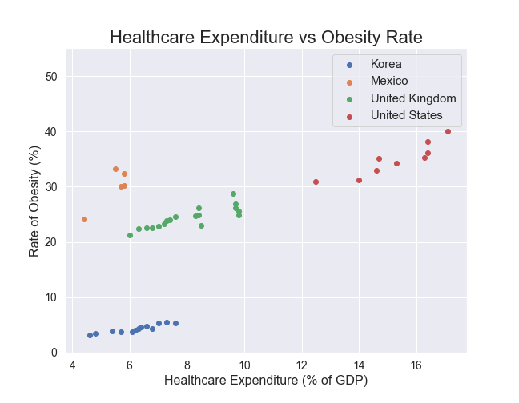

Figure 1. Healthcare costs as a percentage of nation’s gross domestic product vs rate of obesity for each OECD country of interest from 1970 – 2018

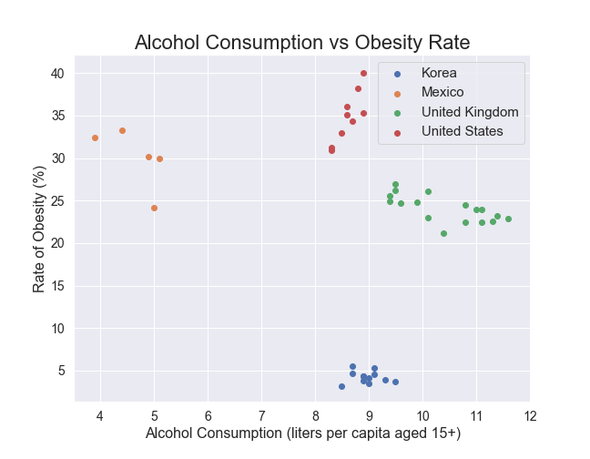

Figure 2. Alcohol consumption in liters per capita (aged 15+) versus rate of obesity for each OECD country of interest from 1970 – 2016.

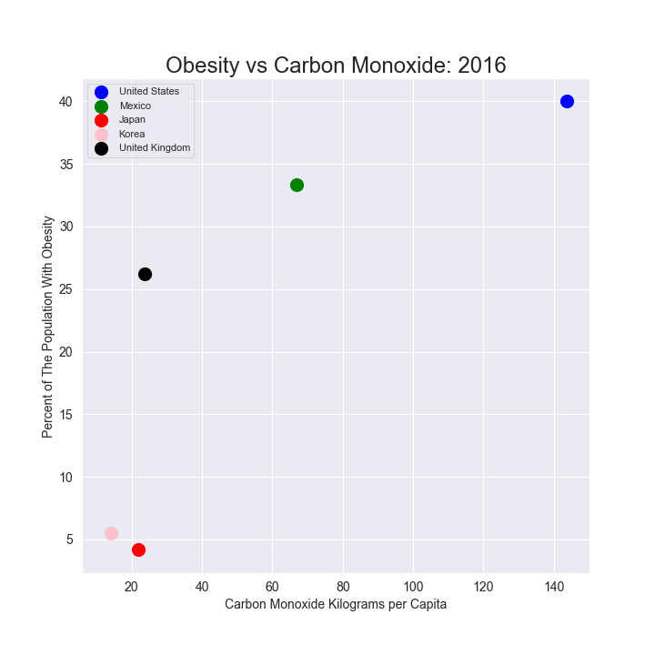

Figure 3. Obesity in percentage of population versus carbon monoxide kilograms per capita in the year 2016 for our target countries.

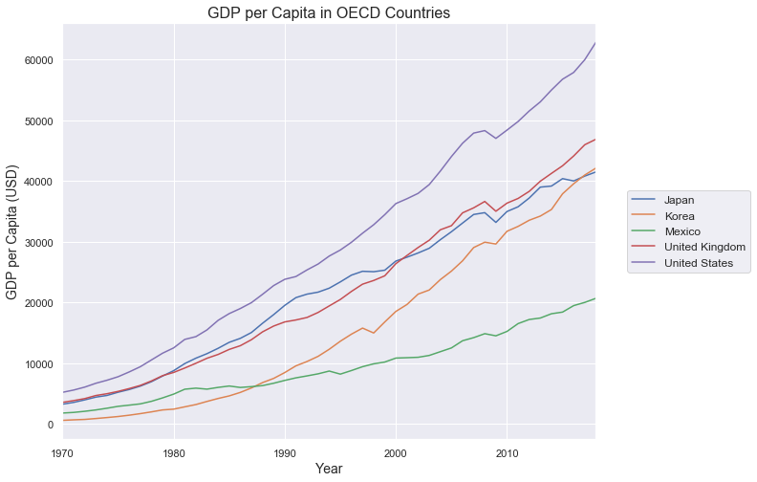

Figure 4: GDP per capita in USD from 1970 to 2018 for five OECD countries.

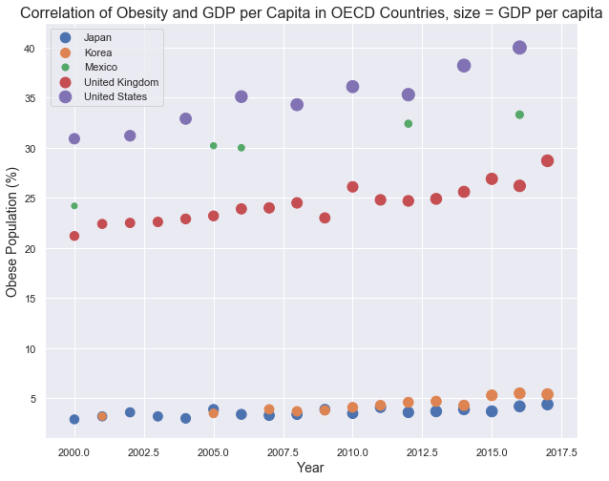

Figure 5: Comparison between the GDP per capita and percentage of people who are obese in five nations from 2000 to 2018.

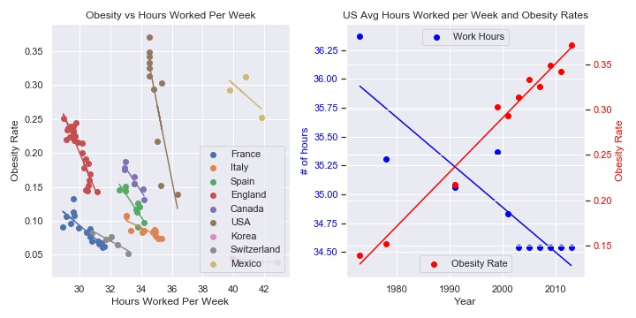

Figure 6: (Left) Obesity and Average Hours Worked Per Week in Selected Countries.

(Right) Average Hours Worked Per Week and Obesity Rates over time in the United States

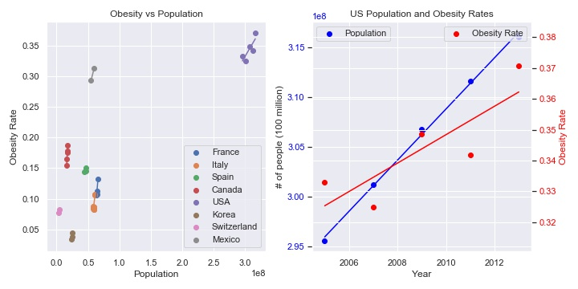

Figure 7: (Left) Obesity Rates and Population in Selected Countries

(Right) Population and Obesity Rates over time in the United States

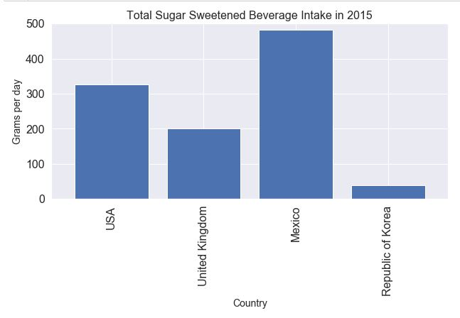

Figure 8: Consumption of Sugar Sweetened Beverages in grams per day by selected countries

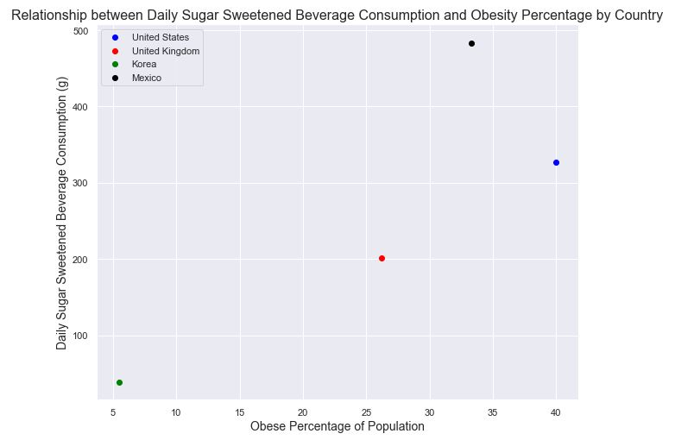

Figure 9: Obesity percentages and daily sugar sweetened beverage consumption by selected countries

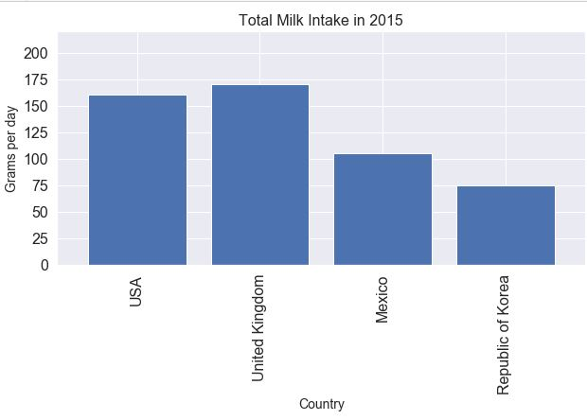

Figure 10: Total consumption of dairy in grams per day by selected countries

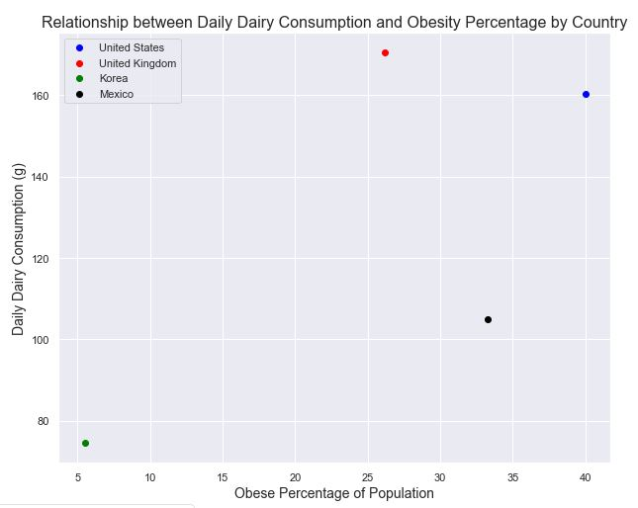

Figure 11: Obesity percentages by population and daily dairy consumption by selected countries

References

An, R., Ji, M., Yan, H., & Guan, C. (2018, May 24). Impact of ambient air pollution of obesity: a systematic review. Retrieved from <https://www.nature.com/articles/s41366-018-0089-y>

Bae, S. G., Kim, J. Y., Kim, K. Y., Park, S. W., Bae, J. Lee, & W. K. (2012). Changes in dietary

behavior among adolescents and their association with government nutrition policies in

Korea, 2005-2009. *Journal of Preventive Medicine & Public Health, 45*(1), 47-59.

Carrington, D. (2018, November 4). Childhood obesity linked to air pollution from vehicles.

Retrieved from [https://www.theguardian.com/environment/2018/nov/04/childhood- obesity-linked-to-air-pollution-from-vehicles](https://www.theguardian.com/environment/2018/nov/04/childhood-  obesity-linked-to-air-pollution-from-vehicles)

Cawley, J., & Meyehoefer, C. (2012). The medical care costs of obesity: An instrumental

variables approach. *Journal of Health Economics, 31*(1), 219-230.

de Bont, J., Casas, M., Barrera-Gómez, J., Cirach, M., Rivas, I., Valvi, D., … Vrijheid, M. (2019, April). Ambient air pollution and overweight and obesity in school-aged children in Barcelona, Spain. Retrieved from <https://www.ncbi.nlm.nih.gov/pubmed/30703612>

Fernald, L. C. H. (2007). Socio-economic status and body mass index in low-income Mexican adults. *Social Science and Medicine, 64*(10), 2030-2042. <https://doi.org/10.1016/j.socscimed.2007.02.002>.

Flegal, K. M., Carroll, M. D., Kit, B. K. & Ogden, C. L. (2012). Prevalence of obesity and trends in the distribution of body mass index among US adults, 1999-2010. *JAMA, 307*(5), 491-497.

HM Government. (2016). Childhood obesity: A plan for action. Retrieved from <https://assets.publishing.service.gov.uk/government/uploads/system/uploads/attachment_data/file/546588/Childhood_obesity_2016__2__acc.pdf>

Kasakove, S. (2020, April 7). 'Cancer Alley' Has Some of the Highest Coronavirus Death Rates in the Country. Retrieved from <https://www.vice.com/en_us/article/pke94n/cancer-alley-has-some-of-the-highest-coronavirus-death-rates-in-the-country>

Kim, J. W., Lee, B. C., Kang, T., & Choi, I. (2013). The current situation of treatment systems for alcoholism in Korea. *Journal of Korean Medical Science, 28*(2), 181-189.

Kratz, M., Baars, T., & Guyenet, S. (2013). The relationship between high-fat dairy consumption and obesity, cardiovascular, and metabolic disease. *Eur J Nutr,* *52*, 1–24. <https://doi.org/10.1007/s00394-012-0418-1>

Lawrence, Felicity. “The Way We Eat Is Killing Us – and the Planet | Felicity Lawrence.” *The Guardian*, Guardian News and Media, 28 Jan. 2019, [www.theguardian.com/commentisfree/2019/jan/28/global-food-killing-humans-planet-climate-change-obesity](http://www.theguardian.com/commentisfree/2019/jan/28/global-food-killing-humans-planet-climate-change-obesity).

Lim, H., Kim, J., Wang, Y., Min, J., Carvajal, N. A., & Lloyd, C. W. (2016). Child health promotion program in South Korea in collaboration with US National Aeronautics and Space Administration: Improvement in dietary and nutrition knowledge of young children. *Nutrition Research and Practice, 10*(5), 555-562.

Lissau, I., Overpeck, M., Ruan, W. J., Hediger, M. L., Due, P., Holstein, B. J., Godeau, E., Maes, L., Casper de Matos, M., Molcho, M., Harel, Y., Nic Gabhainn, S., Välimaa, R., Vereecken, C., & Zaborskis, A. (2004). Body mass index, overweight and obesity in adolescents in Europe and the United States. *Archives of Pediatric and Adolescent Medicine, 158*, 27-33.

Lockyer, Chris. (2014). Obesity: Countries Compared. *NationMaster*. <https://www.nationmaster>. com/country-info/stats/Health/Obesity

Masood, M., & Reidpath, D. D. (2017). Effect of national wealth on BMI: An analysis of 206,266 individuals in 70 low-, middle- and high-income countries. *PloS one*, *12*(6), e0178928. <https://doi.org/10.1371/journal.pone.0178928>

OECD (2020), Hours worked (indicator). doi: 10.1787/47be1c78-en (Accessed on 08 April 2020)

OECD (2020), Overweight or obese population (indicator). doi: 10.1787/86583552-en (Accessed on 23 March 2020) <https://www.who.int/topics/obesity/en/>

Organization for Economic Co-operation and Development. (n.d.) *About OECD*. <https://www.oecd.org/about/>

Park, S. M., Blanck, H. M., Sherry, B. M., Brener, N. M., & O'Toole, T. M. (2012, February). Factors associated with sugar-sweetened beverage intake among United States high school students. Retrieved from https://www.ncbi .nlm.nih .gov/pmc/articles/PMC 4532336/

Parker-Pope, Tara. “Workplace Cited as a New Source of Rise in Obesity.” The New York Times, The New York Times, 26 May 2011, [www.nytimes.com/2011/05/26/health](http://www.nytimes.com/2011/05/26/health) /nutrition/26fat.html.

Particulate Matter (PM) Basics. (2018, November 14). Retrieved from <https://www.epa.gov/pm-pollution/particulate-matter-pm-basics>

Pereira, M. A. (2006). The possible role of sugar-sweetened beverages in obesity etiology: a review of the evidence. *International Journal of Obesity, 30*, S28–S36.

Sayon-Orea, C., Martinez-Gonzalez, M. A., & Bes-Rastrollo, M. (2011). Alcohol consumption and body weight: A systematic review. *Nutrition Reviews, 69*(8), 419-431.

School Meals and Snacks. (n.d.). Retrieved April 21, 2020, from https://stateofchildhoodobesity .org/policy/school-meals/

Sharifi, M., Franz, C., Horan, C. M., Giles, C. M., Long, M. V., Ward, Z. J., Resch, S. C., Marshall, R., Gortmaker, S. L., & Taveras, E. M. (2017). *Pediatrics, 140*(5).

Siddiqi, A., Brown, R., Nguyen, Q. C., Loopstra, R., & Kawachi, I. (2015). Cross-national comparison of socioeconomic inequalities in obesity in the United States and Canada. *International Journal for Equity in Health*, *14*, 1–10. <https://doi.org/10.1186/s12939-015-0251-2>

Simmonds, M., Llewellyn, A., Owen, C. G., & Woolacott, N. (2016). Predicting adult obesity from childhood obesity: A systematic review and meta-analysis. *Obesity Reviews, 17*(2), 95-107.

Stamatakis, E., Wardle, J. & Cole, T. J. (2013). Childhood obesity ad overweight prevalence trends in England: Evidence for growing socio-economic disparities. *International Journal of Obesity, 34*(1).

Steven E. Landsburg. "The Theory of the Leisure Class: An economic mystery: Why do the poor seem to have more free time than the rich?". Slate. Retrieved 2008-01-28.

UK, NHS. “Get Active Your Way.” *NHS Choices*, NHS, 11 June 2018, www.nhs.uk/live-well/exercise/get-active-your-way/.

Wang, Y., Beydoun, M. A., Liang, L., Caballero, B., & Kumanyika, S. K. (2008). Will all Americans become overweight or obese? Estimating the progression and cost of the US obesity epidemic. *Obesity, 16(*10), 2323-2330.

Wang, L. Y., Gutin, B., Barbeau, P., Moore, J. B., Hanes, J. Jr., Johnson, M. H., Cavnar, M., Thornburg, J., & Yin, Z. (2008). Cost-effectiveness of a school-based obesity prevention program. *Journal of School Health, 78*(12), 619-624.

Yeomans, M. R. (2010). Alcohol, appetite, and energy balance: Is alcohol intake a risk factor for obesity? *Physiology & Behavior, 100*(1), 82-89.